
SCHOOL OF COMPUTER APPLICATION
NO SQL PROJECT ON
Student Management System Using MongoDB
Submitted to:
Mr. Harendra Singh
Department: BCA (DS & AI)
DATE: 30th September
Submitted by:
Saloni Nishad
Roll no.: (65)
University Roll no.: (1250258384)
ACKNOWLWDGEMENT
I sincerely express my gratitude to my teacher Mr. Harendra Singh for
giving me the opportunity to work on this NoSQL project titled
“Student Management System Using MongoDB”.
This project helped me understand the basic concepts of NoSQL
databases and learn how MongoDB is used to create, retrieve,
update, Sorting and delete data. I also learned how different query
operators such as greater than, less than, equal to, AND, and OR are
used in MongoDB.
I am thankful to my teacher for the guidance and support provided
throughout the completion of this project.

INTRODUCTION
MongoDB is a popular NoSQL database management system that stores data in the form of documents. Unlike traditional relational databases, MongoDB does not require data to be stored in fixed rows and columns.
In this project, a Student Management System has been created using MongoDB. The database contains information about 50 students, including their name, age, marks, department, and skills.
Different MongoDB operations have been performed on the student data, such as inserting, displaying, updating, deleting, sorting, limiting, and searching records by department. Comparison operators such as $eq, $gt, $lt, $gte, $lte, and $ne, along with logical operators such as $and, $or, and $not, have also been demonstrated.
OBJECTIVES
• To understand the concept of NoSQL databases.
• To learn the basic features of MongoDB.
• To create a database and collection.
• To insert 50 student records.
• To retrieve student records using MongoDB queries.
• To use comparison operators such as $gt, $lt, $eq, $gte, and $ne.
• To understand logical operators such as $and, $or, and $not.
• To understand how MongoDB is used for storing and retrieving student data.

1.CREATE DATABASE
MongoDB Query:
use college
Explanation: Creates or switches to the Student database.
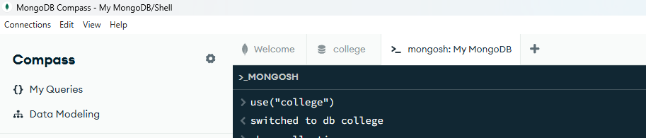

2.CREATE COLLECTION
MongoDB Query:
db. create Collection(“students”)
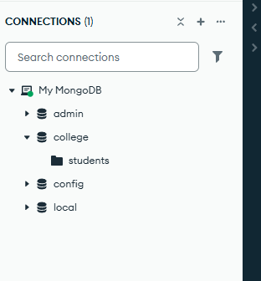
Explanation: Create a collection named students

3. INSERT 50 STUDENTS
MongoDB Query:
db. Students. Insert Many ([])
db.students.insertMany([
{name:"Kunal",age:22,marks:83,department:"CSE",skills:["Python","MongoDB"]},
{name:"Pallavi",age:21,marks:76,department:"ECE",skills:["Java","SQL"]},
{name:"Varun",age:20,marks:89,department:"ME",skills:["AutoCAD","Python"]},
{name:"Shalini",age:23,marks:68,department:"CSE",skills:["Python","AI"]},
{name:"Naveen",age:21,marks:92,department:"ECE",skills:["Java","Python"]},
{name:"Aarti",age:22,marks:74,department:"ME",skills:["AutoCAD","C"]},
{name:"Yuvraj",age:20,marks:81,department:"CSE",skills:["MongoDB","Java"]},
{name:"Ritika",age:21,marks:95,department:"ECE",skills:["Python","SQL","AI"]},
{name:"Manav",age:23,marks:63,department:"ME",skills:["AutoCAD","Python"]},
{name:"Swati",age:20,marks:87,department:"CSE",skills:["Python","MongoDB","AI"]},
{name:"Dev",age:22,marks:79,department:"ECE",skills:["Java","SQL"]},
{name:"Kajal",age:21,marks:91,department:"ME",skills:["Python","AutoCAD"]},
{name:"Rishabh",age:20,marks:66,department:"CSE",skills:["Java","Python"]},
{name:"Poonam",age:23,marks:84,department:"ECE",skills:["SQL","Python"]},
{name:"Tarun",age:22,marks:72,department:"ME",skills:["C","AutoCAD"]},
{name:"Ishita",age:21,marks:96,department:"CSE",skills:["AI","Python","MongoDB"]},
{name:"Sameer",age:20,marks:77,department:"ECE",skills:["Java","SQL"]},
{name:"Bhavna",age:22,marks:88,department:"ME",skills:["Python","AutoCAD"]},
{name:"Ankit",age:23,marks:69,department:"CSE",skills:["Python","Java"]},
{name:"Roshni",age:21,marks:93,department:"ECE",skills:["Python","AI","SQL"]},
{name:"Lakshya",age:20,marks:80,department:"ME",skills:["AutoCAD","C"]},
{name:"Monika",age:22,marks:85,department:"CSE",skills:["MongoDB","Python"]},
{name:"Vishal",age:21,marks:71,department:"ECE",skills:["Java","SQL"]},
{name:"Naina",age:23,marks:90,department:"ME",skills:["Python","AutoCAD","C"]},
{name:"Abhay",age:20,marks:67,department:"CSE",skills:["Python","Java"]},
{name:"Sonia",age:22,marks:86,department:"ECE",skills:["SQL","Python","Java"]},
{name:"Rajat",age:21,marks:78,department:"ME",skills:["AutoCAD","Python"]},
{name:"Khushi",age:20,marks:94,department:"CSE",skills:["AI","MongoDB","Python"]},
{name:"Arnav",age:23,marks:73,department:"ECE",skills:["Java","SQL"]},
{name:"Mansi",age:21,marks:82,department:"ME",skills:["Python","AutoCAD"]},
{name:"Ayush",age:22,marks:89,department:"CSE",skills:["Python","Java","AI"]},
{name:"Reena",age:20,marks:64,department:"ECE",skills:["SQL","C"]},
{name:"Dhruv",age:21,marks:97,department:"ME",skills:["AutoCAD","Python","C"]},
{name:"Payal",age:23,marks:75,department:"CSE",skills:["MongoDB","Java"]},
{name:"Ravi",age:22,marks:83,department:"ECE",skills:["Python","SQL"]},
{name:"Anushka",age:20,marks:91,department:"ME",skills:["Python","AutoCAD"]},
{name:"Gaurav",age:21,marks:70,department:"CSE",skills:["Java","Python"]},
{name:"Meera",age:22,marks:87,department:"ECE",skills:["AI","Python","SQL"]},
{name:"Rohan",age:23,marks:76,department:"ME",skills:["AutoCAD","C"]},
{name:"Tanu",age:20,marks:98,department:"CSE",skills:["Python","MongoDB","AI"]},
{name:"Siddharth",age:21,marks:65,department:"ECE",skills:["Java","SQL"]},
{name:"Kirti",age:22,marks:84,department:"ME",skills:["Python","AutoCAD"]},
{name:"Harshit",age:20,marks:79,department:"CSE",skills:["MongoDB","Python"]},
{name:"Radhika",age:23,marks:92,department:"ECE",skills:["Python","AI","SQL"]},
{name:"Samar",age:21,marks:68,department:"ME",skills:["AutoCAD","C"]},
{name:"Ayesha",age:22,marks:88,department:"CSE",skills:["Java","Python","MongoDB"]},
{name:"Nitin",age:20,marks:74,department:"ECE",skills:["SQL","Java"]},
{name:"Sakshi",age:21,marks:93,department:"ME",skills:["Python","AutoCAD","C"]},
{name:"Varsha",age:23,marks:81,department:"CSE",skills:["AI","Python"]}
])
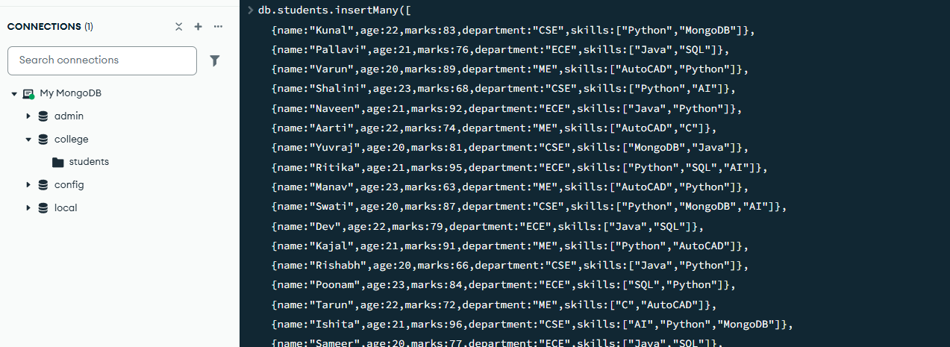

Explanation: Insert multiple student documents into the collection
4. DISPLAY ALL STUDENTS
MongoDB Query:
db. students. find ()
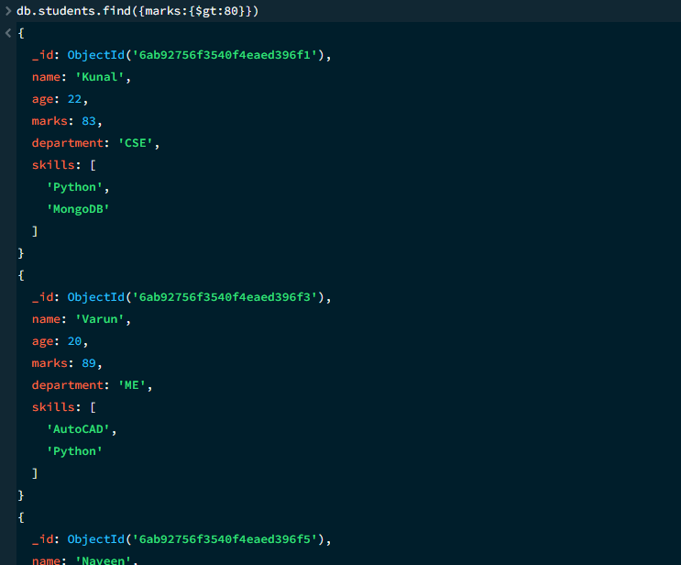
Explanation: Retrieves documents from the students collection

5. EQUAL TO - $eq
MongoDB Query:
db. Students. find({marks:{$eq:85}})
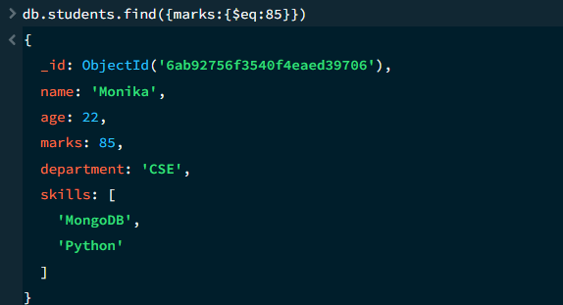
Explanation: Finds students whose marks are exactly 85

6. GREATER THAN - $gt
MongoDB Query:
db.students.find({marks:{$gt:80}})
Explanation: Find students whose marks are greater than 80
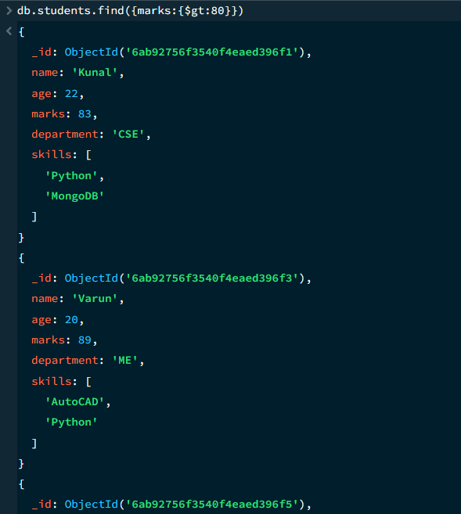

7. LESS THAN - $lt
MongoDB Query:
db.students. find ({marks:{$lt:80}})
Explanation: Find students whose marks are less than 80

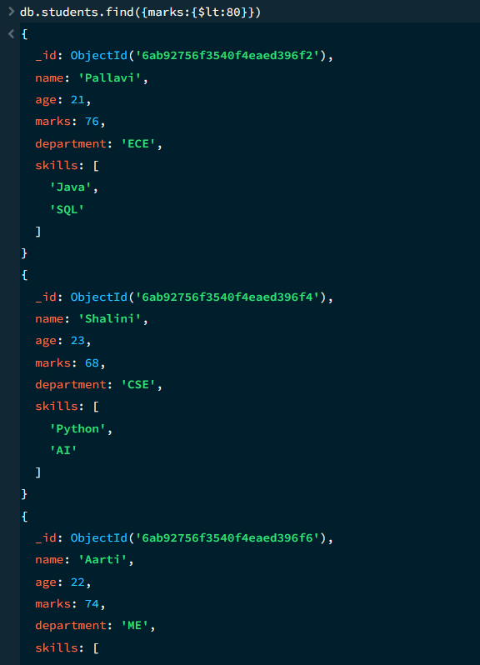

8. GREATER THAN OR EQUAL TO - $gte
MongoDB Query:
db. students. find({marks:{$gte:80}})
Explanation: Find students whose marks are 80 or above
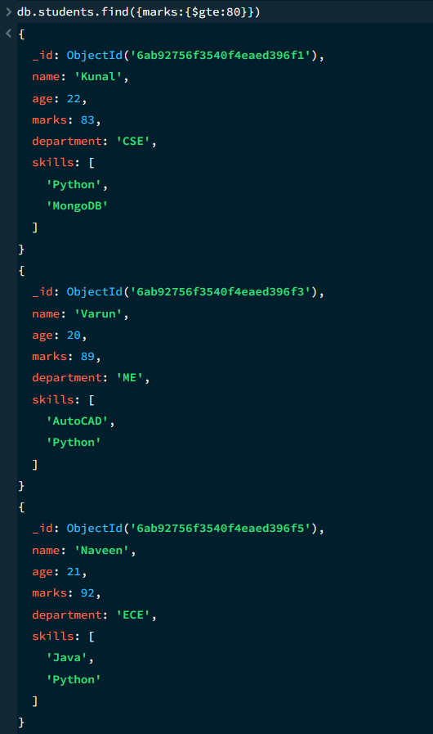
9. LESS THAN OR EQUAL TO - $lte
MongoDB Query:
db. students. find({marks:{$lte:70}})
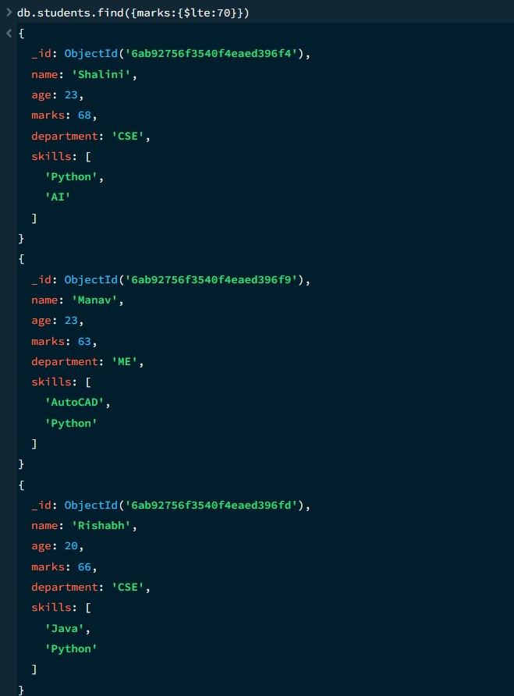
Explanation: Find students whose marks are 70 or below

10. UPDATE OPERATION
MongoDB Query:
db.students.updateOne(
{ name: “Kunal”},
{ $set:{marks:90}}
)
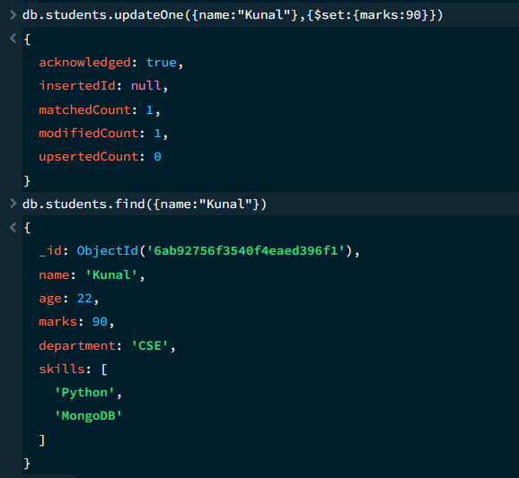
To Check: db.students.find({name:”Kunal”})

11. AND OPERATION - $and
MongoDB Query:
db.students.find({$and:[
{marks:{$gt:70}},
{age:{$lt:23}}]}
)
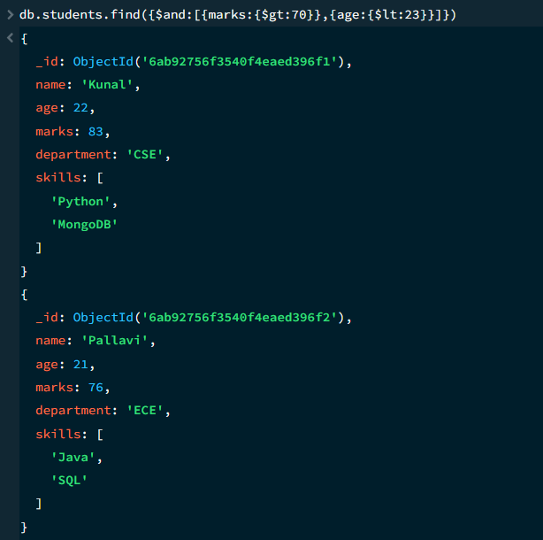
Explanation: Find students satisfying both conditions

12. OR OPERATION - $or
MongoDB Query:
db.students.find({$or:[
{department:"CSE"},
{department:"ECE"}]}
)
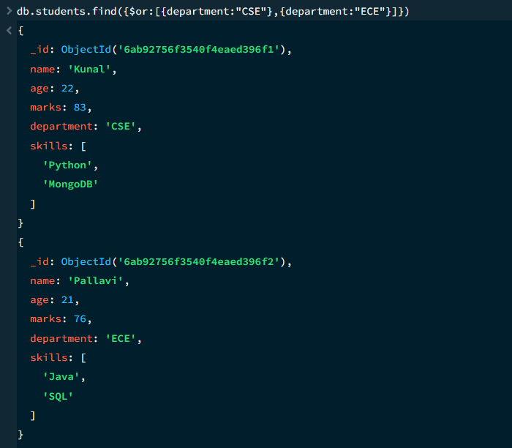
Explanation: Find students from CSE OR ECE

13. SORT OPERATION
A. MongoDB Query:
db.students.find().sort({marks:1})
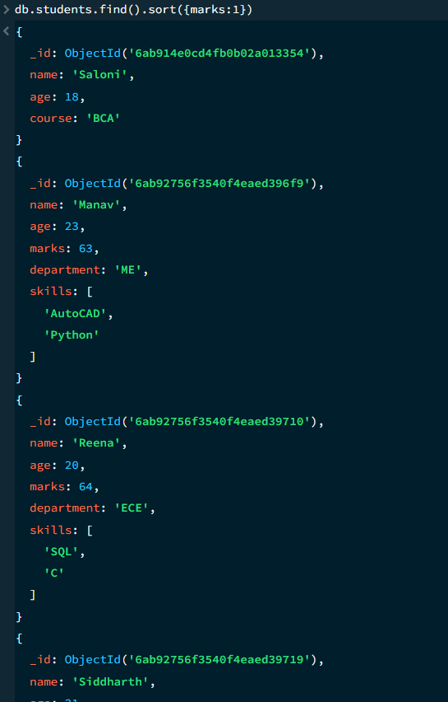
Explanation: Sorts students by marks from lowest to highest. Use 1 for ascending order

B. Mongo Query:
db.students.find().sort({marks:1})
Explanation: Sort students by marks from highest to lowest . Use -1 for descending order
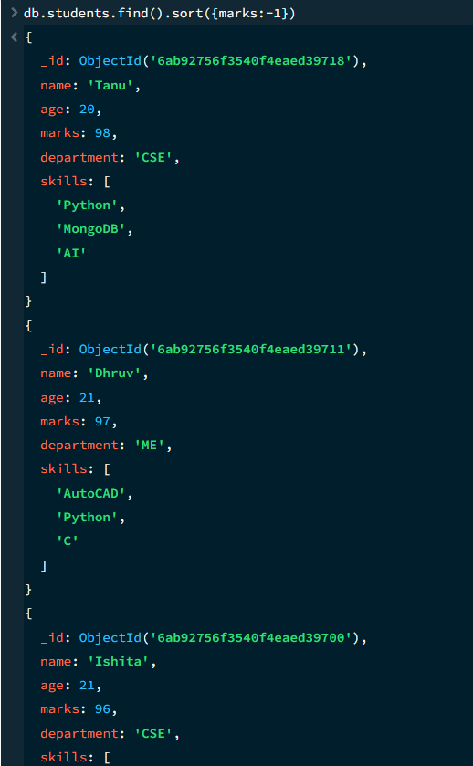

14. LIMIT OPERATION
MongoDB Query:
db.students.find().limit(5)
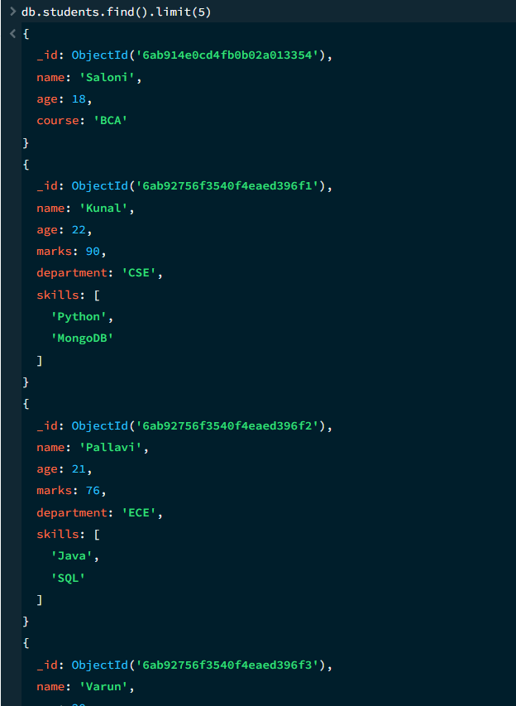
Explanation: Displays only the first five documents

15. SEARCH BY DEPARTMENT
MongoDB Query:
db.students.find({department:"CSE"})
Explanation: Finds all students whose departments are CSE
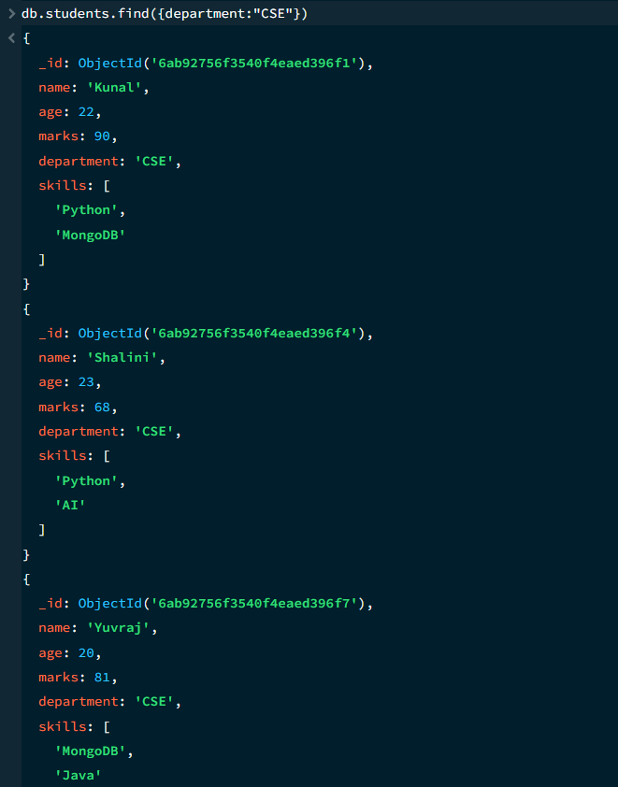

16. DELETE ONE OPERATION
MongoDB Query:
db.students.deleteOne({name:"Kunal"})
Explanation: Deletes one student document whose name is Kunal
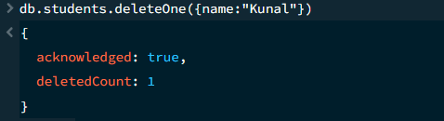

17. DELETE MANY OPERATION
MongoDB Query:
db.students.deleteMany({marks:{$lt:65}})
Explanation: Deletes all student records having marks less than 65
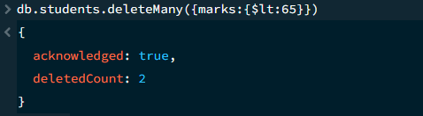

18. COUNT DOCUMENTS
MongoDB Query:
db.students.countDocuments()
Explanation: Counts documents currently present in the collection (performing after the delete function)
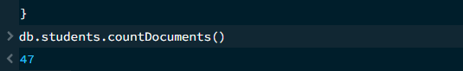

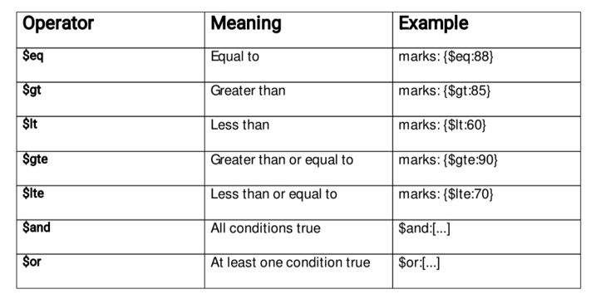
MONGODB OPERATORS USED

CONCLUSION
This project provided practical knowledge of NoSQL databases using MongoDB. A Student Management System containing 50 student records was created, and different MongoDB operations were performed on the data.
Through this project, I learned how to insert, retrieve, update, and delete documents. I also learned how to sort data in ascending and descending order, limit the number of records, search students by department, and use comparison operators such as $eq, $gt, $lt, $gte, $lte, and $ne, along with logical operators such as $and, $or, and $not.
Overall, this project helped me understand how MongoDB can be used to store, manage, and query student data efficiently.

